


CL1002  - Programming Fundamentals | Lab 01  - Problem solving in the context of programming fundamentals, Problem Analysis Charts, Input Process Output, Introduction to flowcharts, Pseudocode, Algorithms, Introduction to scratch

National University of Computer and Emerging Sciences
Fall 2025

Aims and Objectives

The aim of this lab is to equip students with the foundational knowledge and skills necessary to understand and apply fundamental programming concepts. The objectives of this lab are as follows.

1. Equip students with foundational knowledge of fundamental programming concepts.
2. Develop problem-solving skills through real-world examples.
3. Introduce students to the PAC (Problem Analysis Chart) methodology.
4. Familiarize students with IPO (Input-Process-Output) Charts.
5. Teach students how to create and interpret Flowcharts.

6. Understand the concept of pseudocode and its role in program design.

7. Learn the specific keywords and operations used in pseudocode.

8. Develop the ability to write algorithms that outline the logic of a program.

9. Learn scratch programming

Introduction
In this lab we will be covering the following topics
- Problem solving in the context of programming fundamentals.
- Introduction to Problem Analysis Charts.
- Introduction to Input Process Output Table.
- Introduction to flowcharts.
- Pseudocode
- Algorithms
- Introduction to scratch

Objective: 1 Problem Solving
What is Problem solving?
•Definition: Problem-solving in programming is identifying a problem, planning a solution, and executing that solution to achieve the desired result.
•Importance: It’s fundamental in programming because it helps create efficient, effective, and scalable solutions.

Example
Imagine that you have the following image, which is a map of a road leading to the building shown in the picture.
- There is a car and trees.
- The car cannot cross the trees
- The road is divided into squares to calculate the steps of the car.
- Each square is considered as one step.
- The car can be moved omni-directional.
How can the car arrive at the building?
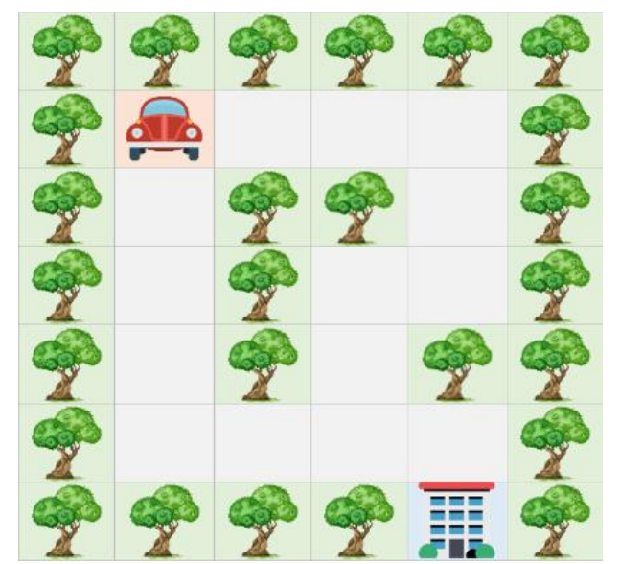

Figure: 1(a) Problem solving

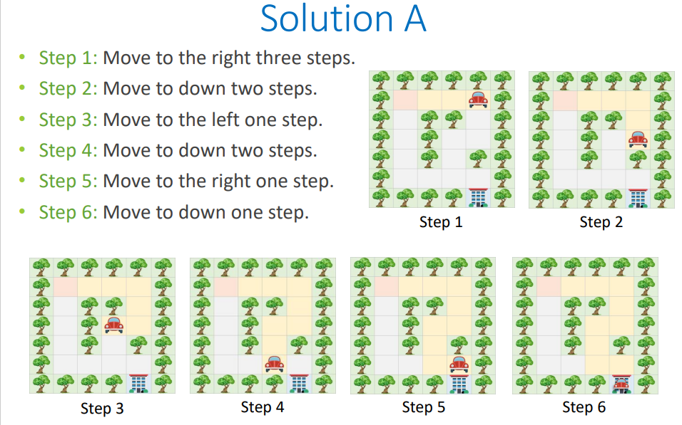
Figure: 1(b) Problem Solving

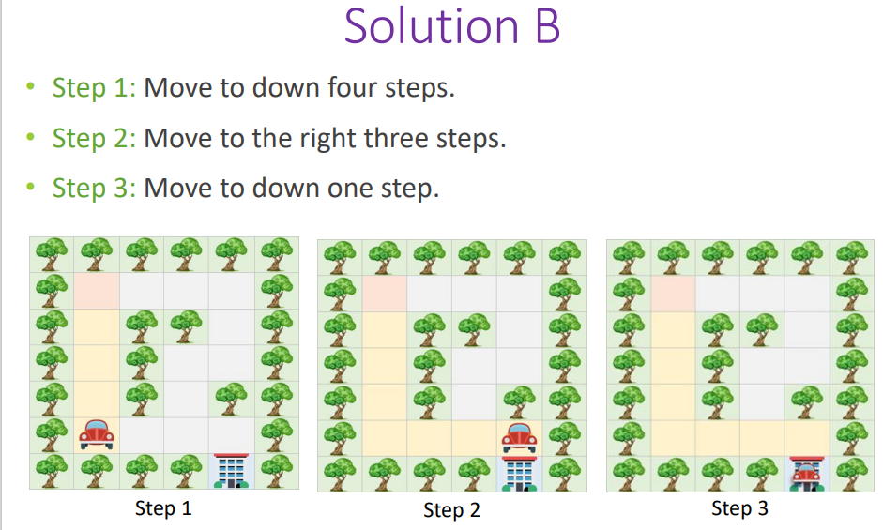
Figure: 1(c) Problem Solving
As we can see Solution A and Solution B are both correct solutions to the same problem, but there are differences in the complexity and efficiency of the solutions.
The cost of Solution A is 10 steps while Solution B is 8, so we consider Solution B a better solution based on the number of steps.
Reducing the number of steps in the previous example means reducing the fuel needed by the vehicle and speeding up the arrival time.

Objective: 2 Problem Analysis Chart
The Problem Analysis Chart (PAC) is a dependent tool used in troubleshooting problems, especially in programming and systems development. It allows problem to be broken down into smaller, more manageable parts and is often used to plan and document the steps needed to solve a problem using a programming language like C.
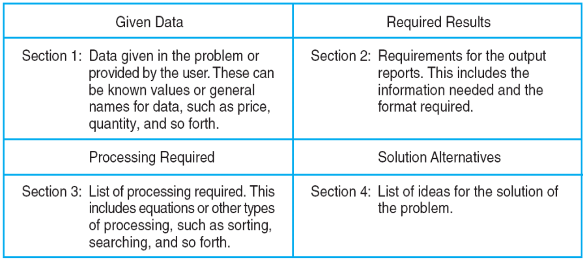
Figure: 2 An Example of a Problem Analysis Chart (PAC)
In a Problem Analysis Chart there are 4 sections that we need to concentrate on. The Top Left section is the data for the problem we are currently trying to solve, so it will include things such as variables, numerical data, percentile and more. The Top Right section is the desired output we require which is what the problem is based on. The bottom left section is the processing section where the necessary steps are enlisted to ensure the correct output for the required results, and the bottom right section are alternate solutions as a problem can have multiple solutions to achieve the same result.

Example
We have a problem in which we want to calculate the gross pay of an employee at the department store that you were previously working as a cashier (assume you are the general manager of that department store). Since you studied well you remember the formula for calculating the formula for gross pay. But I will write it down anyway for ease of use.

GrossPay = Hours*PayRate
Payrate = 20$/HR.
Hours = 12

We need to develop a PAC chart for the above-mentioned problem.
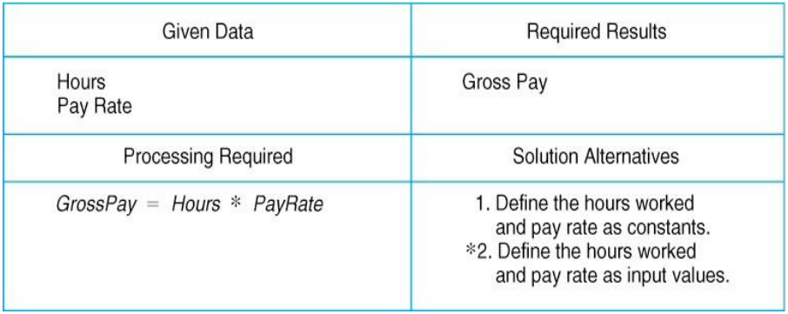
Figure: 3 Example of PAC chart
In the problem listed we identified that Hours and Pay Rate are the data that we are given so it is fed into the top left section of the chart. We require the gross pay of the employee so that goes to our required results section. A formula is required to calculate the gross pay so we can put it in the processing section, finally we can have multiple solutions to the problem as we can have an adaptive pay scale and hour scale.
Some more problems to solve
Create PAC Charts of the following problems
Problem #1
Imagine you are designing a student details record system. Create a PAC chart that collects information from the user about a student and calculates the obtained marks and percentage based on the marks entered. The program should include the following steps:
- Ask the user to enter the student’s ID, student’s Name, marks for Subject 1, marks for Subject 2, and marks for Subject 3.
- Calculate the obtained marks by adding the marks for all three subjects.
- Calculate the percentage obtained by dividing the obtained marks by the maximum possible marks (assuming each subject has a maximum of 100 marks) and multiplying by 100.
- Display the student’s details (ID and Name), the obtained marks, and the calculated percentage.
Problem #2
Create PAC chart that calculates the area of a rectangle. Ask the user for the length and width, then display the calculated area?
Problem #3
Design a PAC chart that converts Celsius to Fahrenheit. Ask the user for a temperature in Celsius and display its equivalent in Fahrenheit using the formula: Fahrenheit = (Celsius * 9/5) + 32.

Objective: 3 Input Process Output
The IPO (Input-Process-Output) model is used in programming and system design for several important reasons. It provides a clear, structured way to conceptualize and develop software by breaking down the process into three fundamental steps: Input, Process, and Output.
IPO Chart shows:
• What data item are input.
• What processing takes place on that data.
• What information will be the result, the output.
• Where in the solution the processing takes place.
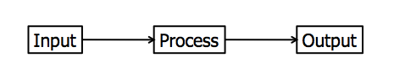

Example
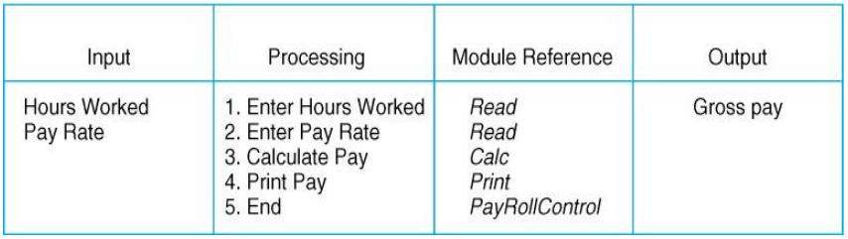
Figure: 5 An example IPO Chart of a Payroll System
In an IPO Chart we have 4 sections. Input, Processing, Module Reference and Output. Like the PAC chart we need to identify what are the input variables in our problem. The processing section has the same effect as the PAC chart but now in a more detailed layout where each step is enlisted. The Module Reference is one change from the PAC chart where each step of the processing section is converted into a command to which a computer will interpret. Such as Read, Calculate, Print, Loop, Write and Program control.
Some more problems to solve 🙁
Problem #4
Sara is keeping track of her daily step count using a fitness tracker. Over the past week, she walked 8000 steps on Monday, 9500 steps on Tuesday, 7500 steps on Wednesday, 10500 steps on Thursday, 6200 steps on Friday, 8800 steps on Saturday, and 7100 steps on Sunday. Calculate Sara’s average daily step count for the week. (create an IPO chart for it)

Objective: 4 Flowcharts
Flow charts are diagrams showing the exact sequence of logical steps. They use geometrical shapes and arrows to show processes, relationships, and data/process flow. In other words, flowcharts depict decisions and results of them.
In different fields, flowcharts are often used to analyze and manage processes. To put it simply, it helps you visualize what the processes look like. That way, you can see all the bottlenecks and flaws in them. The act of creating a chart is called flowchart.
 | Flowline: Indicates the flow of logic by connecting symbols.
 | Terminals: Represents the start and the end of a flowchart.
 | Input/Output: Used for input & Output operation.
 | Processing: Used for arithmetic operations and data-manipulations.

Example

Table: 1 basic flowchart

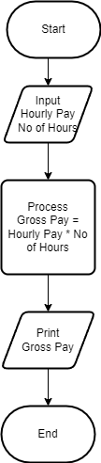

Figure: 6 Example of Flowchart
The start and End section of the Flow Chart represent the programs start and end boundaries. The Parallelogram where the Input and Print statements represent the Inputs and Outputs of the Program, and the Square Box represents the Processing required to achieve the desired output.

Objective: 5 PSEUDOCODE
Pseudocode is a way to express an algorithm or program logic in a human-readable form, using plain language and simple notations that resemble programming constructs. It serves as an intermediate step between the problem statement and the final implementation in a programming language. Pseudocode does not follow strict syntax rules like a programming language, but it uses common structures such as loops, conditionals, and function calls to outline the logic clearly.
Pseudocode Conventions:
- Start/End: Indicate where the pseudocode begins and ends.
- Input/Output: Specify inputs and outputs.
- Process Steps: Use plain language to describe actions, e.g., SET, ADD, SUBTRACT, PRINT.
- Conditionals: Use IF, THEN, ELSE, ENDIF.

Example
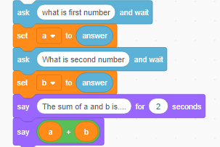
- start
- Ask the user: "What is first number"
- Read input and store it in a
- Ask the user: "What is second number"
- Read input and store it in b
- Set sum = a + b
- Display: "The sum of a and b is..."
- Display the value of sum for 2 seconds
- End

In this example we are taking two integer numbers as input and adding them to a variable sum. After addition a decision is made if the value in the sum variable is greater than zero it returns a print statement that the variable is positive otherwise the variable is negative.
Some problems to solve.
- Find the maximum number in any of three variables.
- Take three variables as input and add them without using the + operator (Use your head for this)
- Create a small calculator which only does ‘+’ or ‘-‘Operations. (Hint: Take three variable inputs with one being used for the operator)

Objective: 6 Algorithm
An algorithm is a finite set of instructions that, if followed, accomplishes a particular task.
OR
An algorithm is a set of obvious, logical, and sequential steps that solve a specific problem.
Characteristics of a Good Algorithm:
- Clear and Unambiguous: Each step is precisely defined.
- Finite: It has a definite end.
- Efficient: It accomplishes the task using minimal resources.

Example
Write an algorithm that can calculate the area of a rectangle. The width and the height of the rectangle should be taken from the user.
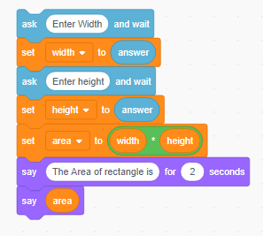
Note: Area = Width × Height
Solution A – Good:
1. Ask the user to enter Width
2. Ask the user to enter Height
3. Set Area to (Width × Height)
4. Display Area for the user

• You can describe the steps in your way, but your description of the steps should be obvious, logical, and sequential.
Solution B - Bad:
1. Ask the user to enter Width
2. Ask the user to enter Height
3. Calculate Area
4. Display Area for the user
The reason for considering Solution B as a bad solution:
Step 3 is not clear because it does not explain how we can calculate Area. So, this algorithm is bad because its steps are not obvious.
Solution C - Bad:
1. Set Area to (Width × Height)
2. Ask the user to enter Width
3. Ask the user to enter Height
4. Display Area for the user
The reasons for considering Solution C as a bad solution:
We don't know what Width and Height at Step 1 are. In other words, Width and Height have not been defined before Step 1, so we cannot use them because they do not exist yet.
What about Step 2 and Step 3? Width and Height are defined there! After Step 2, Width does exist, but Height does not. After Step 3, Height does exist. Both Width and Height are available to be used at or after step 4.
So, this algorithm is bad because its steps are not correctly sequential.
Solution D - Bad:
1. Set Area to (Width × Height)
2. Display Area for the user
The reasons for considering Solution D as a bad solution:
• Step 1 tells us to multiply Width and Height, but we don't know what Width and Height are. Even, they have not been defined in any steps of the algorithm.
• So, this algorithm is bad because of the illogical step, which is using unknown things (Width and Height).

Objective: 7 Introduction to Scratch
Visual Programming Language (VPL) is an application development environment designed on a graphical block-based programming model.

Scratch Interface
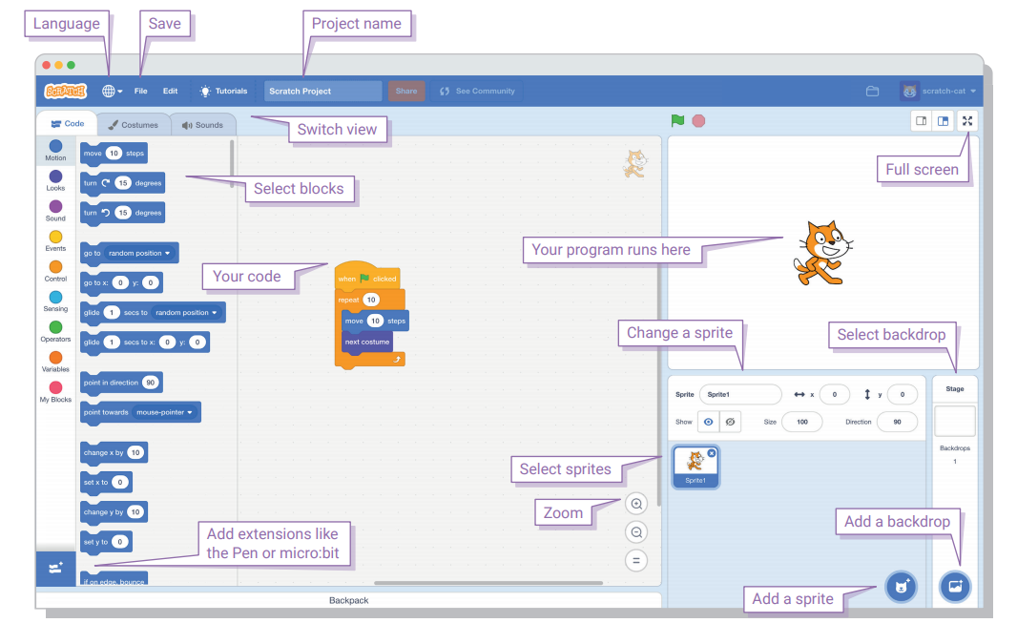

Example#1: Writing our first script in a scratch to print “Hello” to the world.

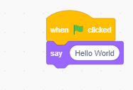

#include <stdio.h>
int main()
{
printf(“Hello World”);
}

Example#2: Prompting your Name and printing “Hello” to your Name.

Script: Output:

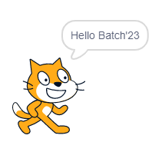
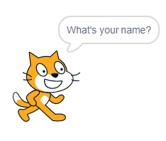
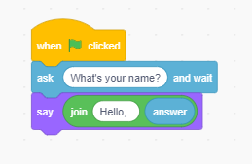

Example#3: Asking your Name and saying by speaking “Hello” to your Name.
Script:
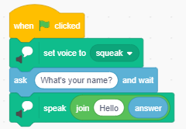
Example#4: Setting Grid Backdrop and moving spirit onto the xy-axis and draw square on the screen.

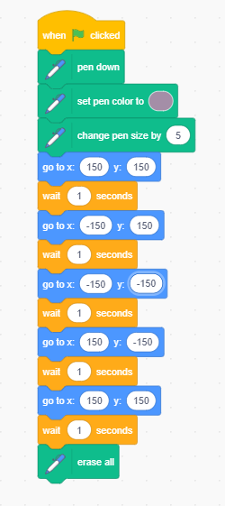
Script: Output:
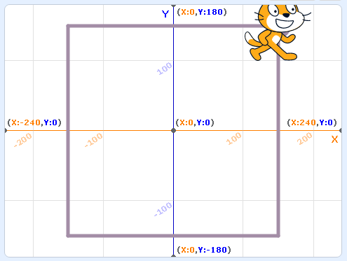

Example#5: Write a script of input two numbers, add two numbers and print the sum of numbers.
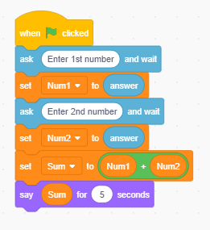
Script: Output:
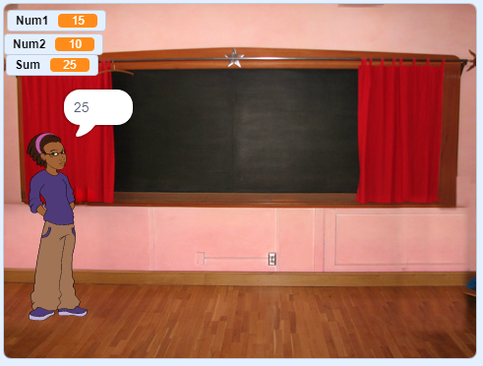

Example#6: Write a script to find an area of circle
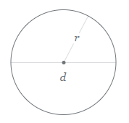
Formula:
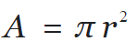

Script: Output:
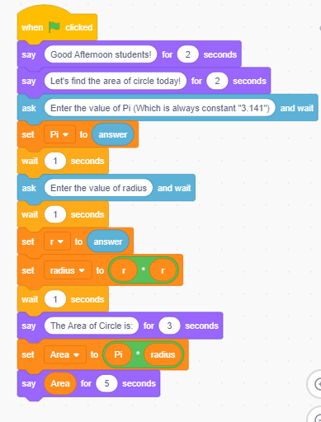
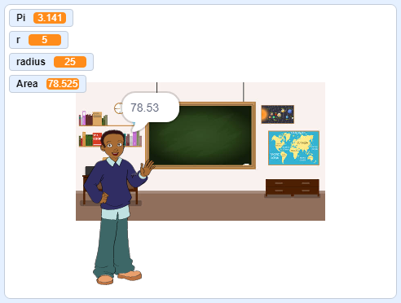

Example#7: Conversation between two scripts when clicked on the spirit.

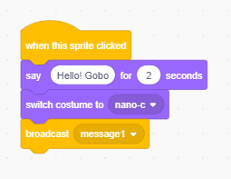
Spirit#1

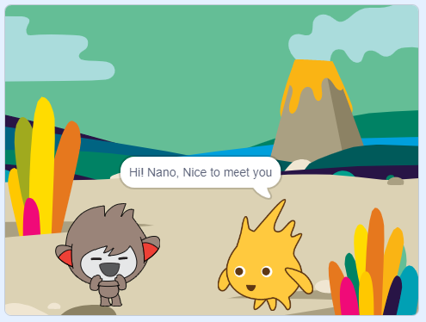

Spirit#2
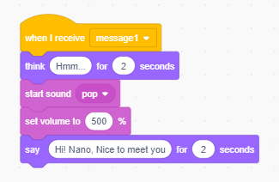

LAB EXERCISES
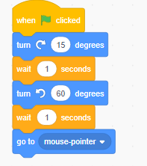
- Write algorithm for the above code and draw flow chart for it.
Solution
Algorithm:
- Start when the green flag is clicked.
- Turn the sprite 15 degrees clockwise.
- Wait for 1 second.
- Turn the sprite 60 degrees clockwise.
- Wait for 1 second.
- Move the sprite to the mouse pointer position.
Flowchart

- Consider the problems given in the PAC chart above. Write the algorithms for each of those problems [Problem 1, 2 and 3]. You only need to write the algorithms — there is no need to explain the PAC chart details.

